- Photograph and Videos: Still Photograph
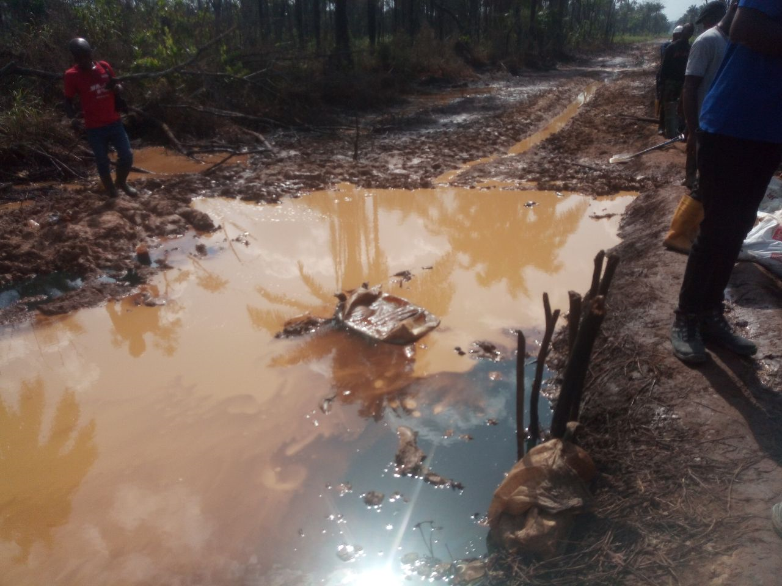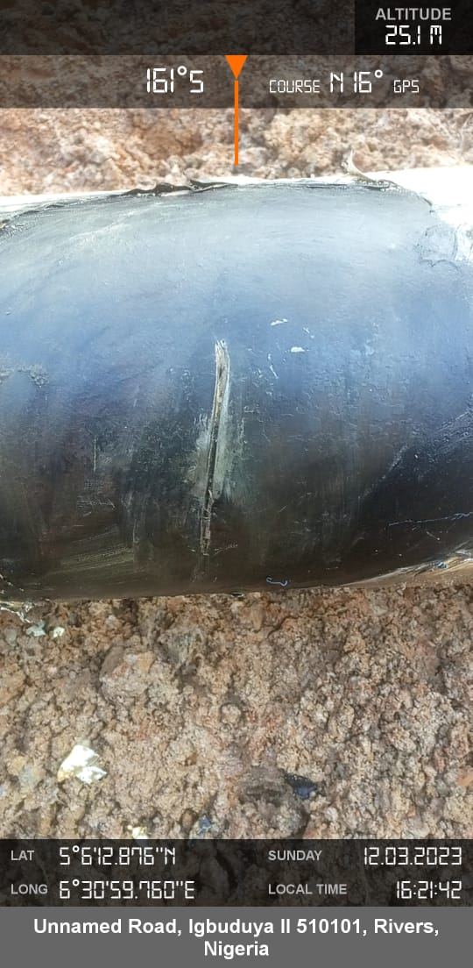
Figure 1: Arrow showing initial status/ spill impact Figure 2: Arrow showing Spill point

